**Spring Data JPA - Quick Example**

**Software Pre-requisites**

• MySQL Server 8.0

• MySQL Workbench 8

• Eclipse IDE for Enterprise Java Developers 2019-03 R

• Maven 3.6.2

**Step 1:** Create a Eclipse Project using Spring Initializr

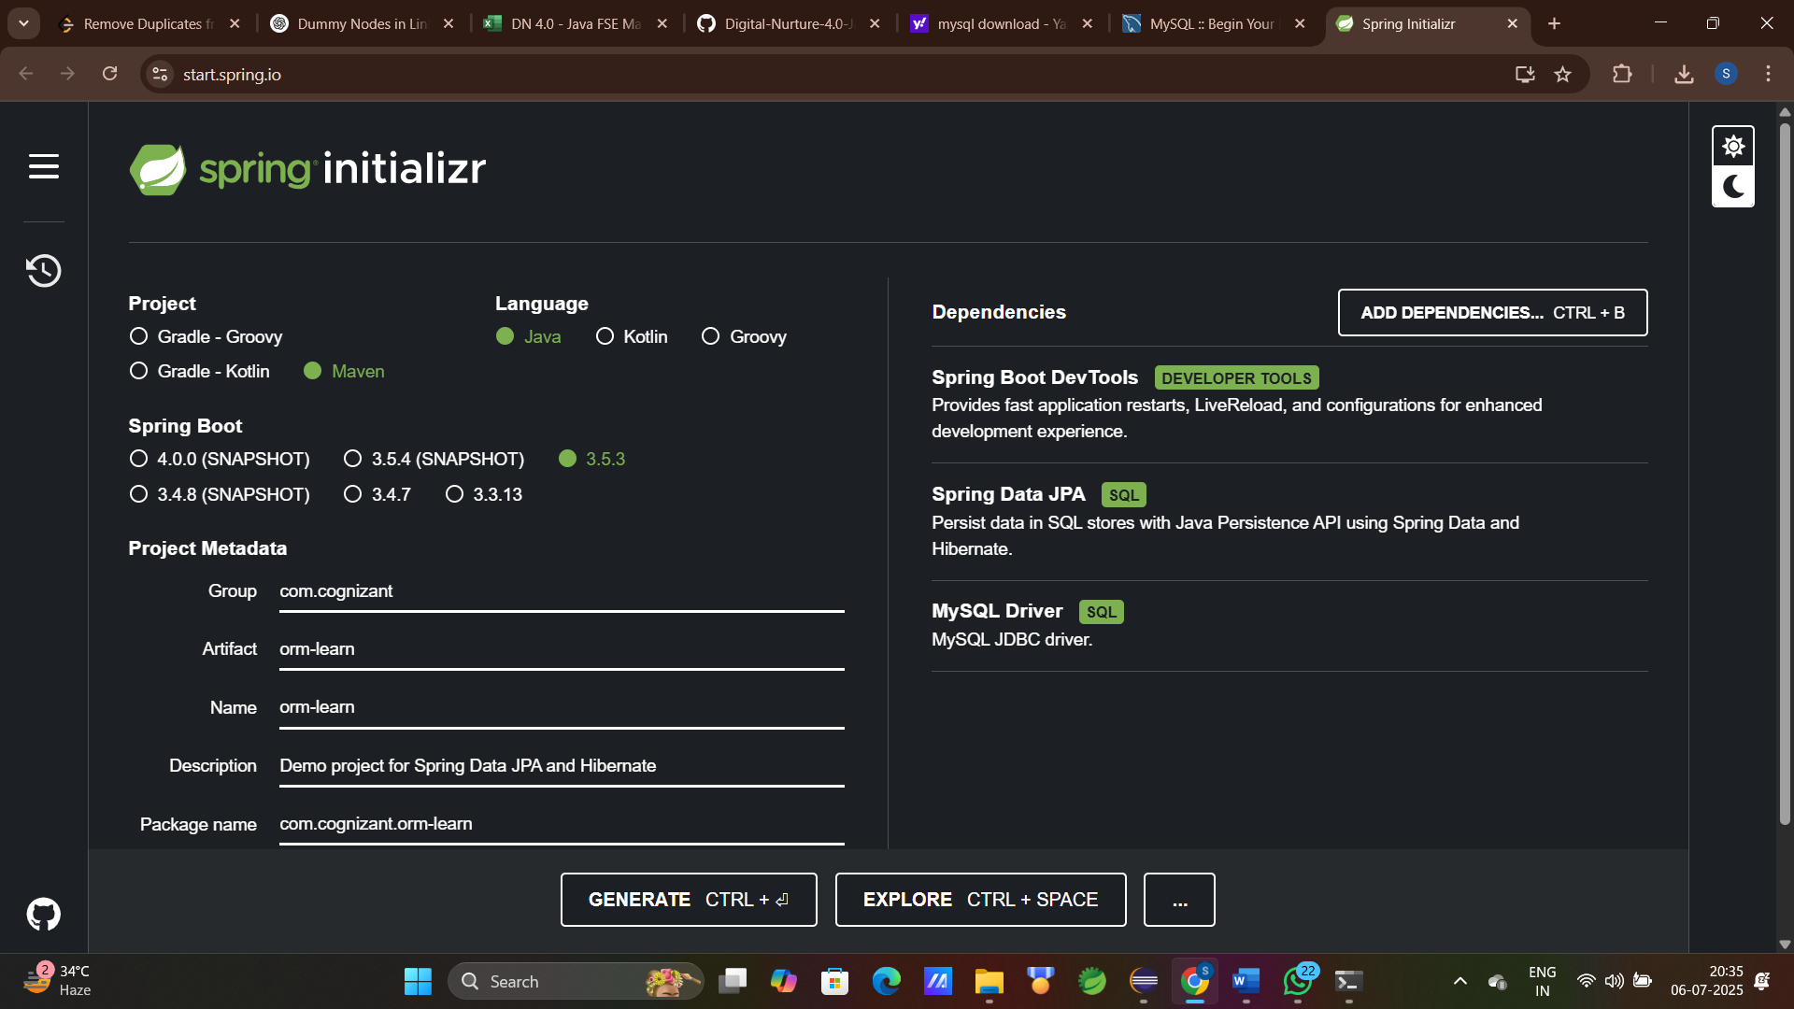

**Step 2:** Extract the zip in root folder to Eclipse Workspace and Import the project in Eclipse

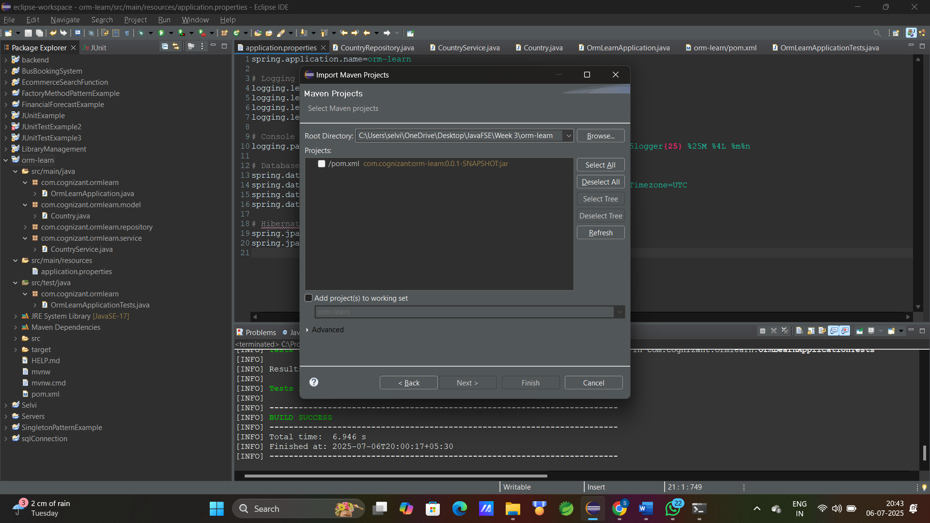

**Step 3:** open MySQL client and create schema

Command : mysql> create schema ormlearn;  
 mysql> use ormlearn;  
create table country and insert values

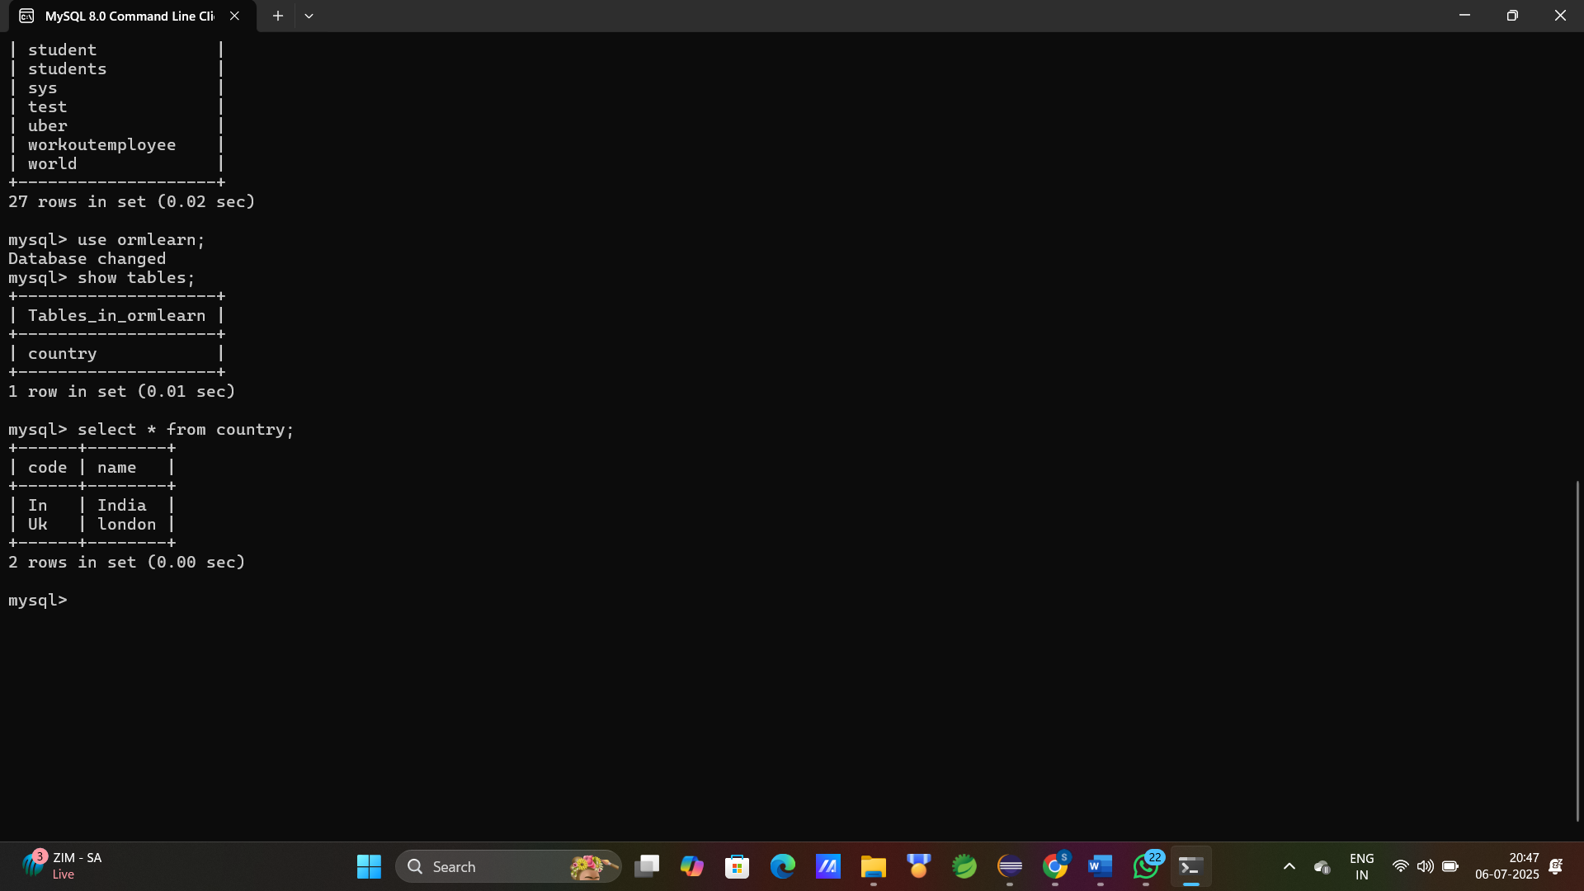

**Step 4:** Setup application.properties and pom.xml(add required dependencies)

application.properties

spring.application.name=orm-learn

# Logging configuration

logging.level.org.springframework=info

logging.level.com.cognizant=debug

logging.level.org.hibernate.SQL=trace

logging.level.org.hibernate.type.descriptor.sql=trace

# Console log pattern

logging.pattern.console=%d{dd-MM-yy} %d{HH:mm:ss.SSS} %-20.20thread %5p %-25.25logger**{25}** %25M %4L %m%n

# Database configuration

spring.datasource.driver-class-name=com.mysql.cj.jdbc.Driver

spring.datasource.url=jdbc:mysql://localhost:3306/ormlearn?useSSL=false&serverTimezone=UTC

spring.datasource.username=root

spring.datasource.password=root

# Hibernate & JPA configuration

spring.jpa.hibernate.ddl-auto=validate

spring.jpa.database-platform=org.hibernate.dialect.MySQLDialect

pom.xml

<?xml version="1.0" encoding="UTF-8"?>

<project xmlns="http://maven.apache.org/POM/4.0.0" xmlns:xsi="http://www.w3.org/2001/XMLSchema-instance"

xsi:schemaLocation="http://maven.apache.org/POM/4.0.0 https://maven.apache.org/xsd/maven-4.0.0.xsd">

<modelVersion>4.0.0</modelVersion>

<parent>

<groupId>org.springframework.boot</groupId>

<artifactId>spring-boot-starter-parent</artifactId>

<version>3.4.8-SNAPSHOT</version>

<relativePath/> <!-- lookup parent from repository -->

</parent>

<groupId>com.cognizant</groupId>

<artifactId>orm-learn</artifactId>

<version>0.0.1-SNAPSHOT</version>

<name>orm-learn</name>

<description>Demo project for Spring Boot JPA and Hibernate</description>

<url/>

<licenses>

<license/>

</licenses>

<developers>

<developer/>

</developers>

<scm>

<connection/>

<developerConnection/>

<tag/>

<url/>

</scm>

<properties>

<java.version>17</java.version>

</properties>

<dependencies>

<dependency>

<groupId>org.springframework.boot</groupId>

<artifactId>spring-boot-starter-data-jpa</artifactId>

</dependency>

<dependency>

<groupId>org.springframework.boot</groupId>

<artifactId>spring-boot-devtools</artifactId>

<scope>runtime</scope>

<optional>true</optional>

</dependency>

<dependency>

<groupId>com.mysql</groupId>

<artifactId>mysql-connector-j</artifactId>

<scope>runtime</scope>

</dependency>

<dependency>

<groupId>org.springframework.boot</groupId>

<artifactId>spring-boot-starter-test</artifactId>

<scope>test</scope>

</dependency>

</dependencies>

<build>

<plugins>

<plugin>

<groupId>org.springframework.boot</groupId>

<artifactId>spring-boot-maven-plugin</artifactId>

</plugin>

</plugins>

</build>

<repositories>

<repository>

<id>spring-snapshots</id>

<name>Spring Snapshots</name>

<url>https://repo.spring.io/snapshot</url>

<releases>

<enabled>false</enabled>

</releases>

</repository>

</repositories>

<pluginRepositories>

<pluginRepository>

<id>spring-snapshots</id>

<name>Spring Snapshots</name>

<url>https://repo.spring.io/snapshot</url>

<releases>

<enabled>false</enabled>

</releases>

</pluginRepository>

</pluginRepositories>

</project>

**Step 5:** create new package for model

Path: src/main/java/com.cognizant.ormlearn.model.Country

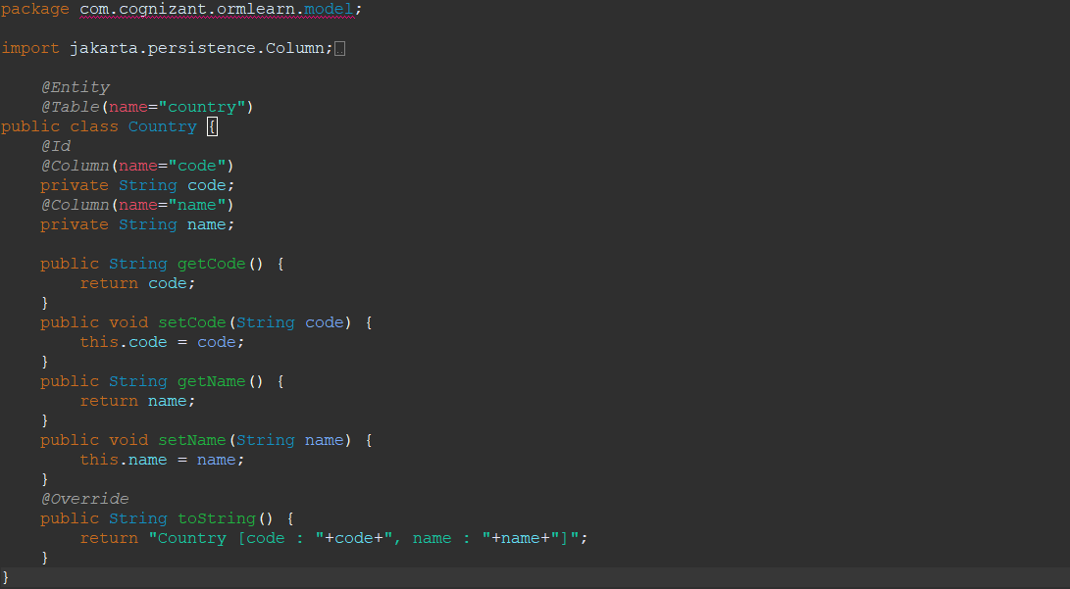

**Step 6:** create new package for Repository

Path: src/main/java/com.cognizant.ormlearn.repository.CountryRepository

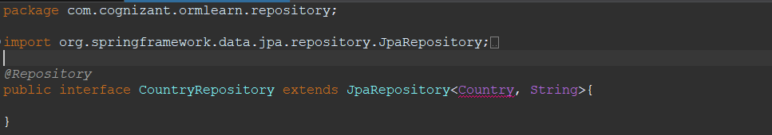

**Step 7:** create new package for Service

Path: src/main/java/com.cognizant.ormlearn.service.CountryService

package com.cognizant.ormlearn.service;

import java.util.List;

import org.springframework.beans.factory.annotation.Autowired;

import org.springframework.stereotype.Service;

import com.cognizant.ormlearn.model.Country;

import com.cognizant.ormlearn.repository.CountryRepository;

import jakarta.transaction.Transactional;

*@Service*

public class CountryService {

*@Autowired*

private CountryRepository countryRepository;

*@Transactional*

public List<Country>getAllCountries(){

return countryRepository.findAll();

}

}

**Step 8:** java class for OrmLearnApplication

Path: src/main/java/com.cognizant.ormlearn.OrmLearnApplication

package com.cognizant.ormlearn;

import java.util.List;

import org.slf4j.Logger;

import org.slf4j.LoggerFactory;

import org.springframework.boot.SpringApplication;

import org.springframework.context.ApplicationContext;

import org.springframework.boot.autoconfigure.SpringBootApplication;

import com.cognizant.ormlearn.model.Country;

import com.cognizant.ormlearn.service.CountryService;

*@SpringBootApplication*

public class OrmLearnApplication {

private static final Logger ***LOGGER*** = LoggerFactory.*getLogger*(OrmLearnApplication.class);

private static CountryService *countryService*;

public static void main(String[] args) {

ApplicationContext context = SpringApplication.*run*(OrmLearnApplication.class, args);

*countryService* = context.getBean(CountryService.class);

***LOGGER***.info("Inside main");

*testGetAllCountries*();

}

private static void testGetAllCountries() {

***LOGGER***.info("Start");

List<Country> countries = *countryService*.getAllCountries();

***LOGGER***.debug("countries={}", countries);

***LOGGER***.info("End");

}

}

**Step 9:** java class for OrmLearnApplicationTest

Path: src/test/java/com.cognizant.ormlearn.OrmLearnApplicationTest

package com.cognizant.ormlearn;

import org.junit.jupiter.api.Test;

import org.springframework.boot.test.context.SpringBootTest;

*@SpringBootTest*(classes = OrmLearnApplication.class)

public class OrmLearnApplicationTests {

*@Test*

void contextLoads() {

}

}

**Output:**

